The figure on the next page shows the actual layout of the project on which the trains will function/run. The numbers written on the layout are assumed and are not to be considered as final.

**Project Brief**

Trains will function/run from one point (section) to another (station to station). The user interface device will request the user to input the actual point from which the trains should be installed. The Power to the train will be provided according to the location of the engine of the train on a particular section.

**My project**

The project deals with collision avoidance system which is designed and implemented in such a way that any possible collision between the trains running on the layout can be detected and avoided.

There are 2 kinds of collision which can occur on the model below.

* Head-on collision (2 trains running into each other)
* Head-way collision (one train running behind another train and colliding)

The collision avoidance system does not deal with scheduling the train and allocating sections that the train is suppose to run on

Therefore, in other words, the user selects the destination of the train through the interface and the scheduling system provides the section details and the route the train will take.

The collision avoidance system will however verify if the train is running on the section specified by the scheduling system.

30

27

19

16

13

10

35

8

7

6

5

4

3

2

1

28

29

31

9

32

24

20

18

17

15

14

33

34

21

24

12

26

25

11

22

23

The collision avoidance system will have the following features

* Add a train to the network
  + Enter the length of the train (The user needs to provide the basic features of the train before a train can be installed on the network)
    - Check how many section the train is occupying. (Each section will have the length through which we can know how many sections the train occupies which is important to avoid collision. The location of the ENGINE of the train will be provided by the other student project)
  + Enter the mass/weight of the train (This feature is required to calculate the braking rate of the train)
  + Enter the section on which the train is required to be installed.
    - If there is no train running on the layout then the train can be installed anywhere on the layout without any verification.
  + If one or more than one trains are running on the layout then the new train can be installed only 4 sections away from the existing train only if the junction lock is not applied (more on the junction locks later in the design)
  + Enter the destination of the train
    - User will be required to input the destination through the interface, the scheduling system will provide the collisions detection system (along with other systems which require to know the path the train will follow) the shortest path or the route that the train should take to reach its desired destination.
  + Enter the priority of the train
    - Lets the system decide which train should be given the priority of the section/tracks.
* Start the train
* Speed according to the surrounding trains
  + If any train on the (1st) same track – apply emergency brakes
    - Should never occupy but in case of emergency
  + If any train on the (2nd) next track – apply brakes
  + If any train on the (3rd) track – speed – slow
  + If any train on the next (4th ) track – speed - medium
  + If no train in any of the following 5 track – speed maximum
* Stop the train
  + The collision system will detect the collision and accordingly give the information to the user through the interface about the future collision, available alternative and other details to the user.
    - In case of emergency the system will automatically apply the brakes.
* Give the information about the number of trains running on the layout and their exact location (Location will be provided by the location tracking project)

The features discussed above are not enough to avoid collision between the trains. A collision is more likely to occur on or near the junctions where two trains (can) meet or a junction leading to 2 different ways.

**The collision avoidance system shall incorporate the following points to avoid the possibility of a head on collision.**

Whenever a train is installed on any section

Verify collision avoidance system safety measurements discussed above

The collision avoidance system will search for the next junction the train is going towards and thereby lock it to avoid any train from coming towards it.

To explain the above point much more clearly consider the below example

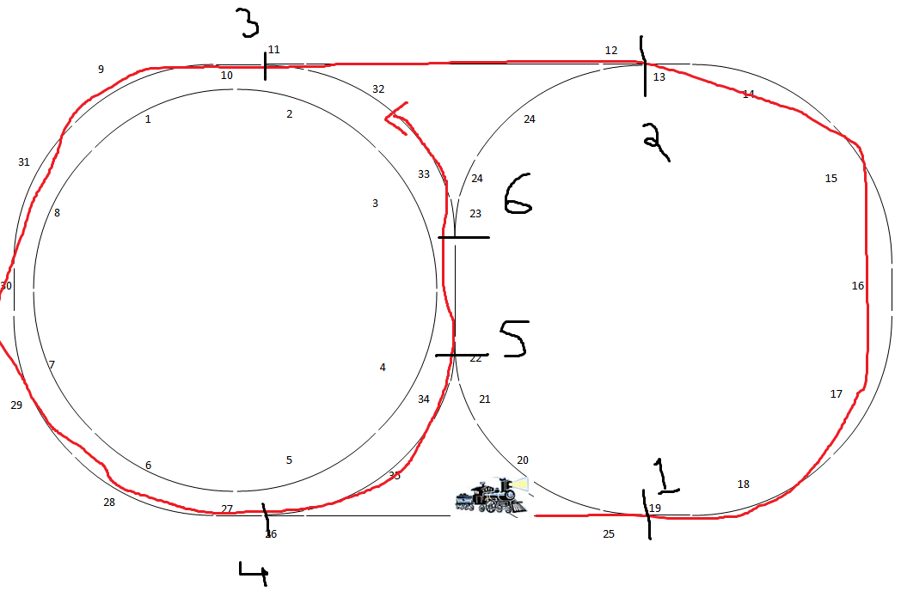

The train (in black) is installed at the particular section as displayed in the image above and the red lines depicts the section and the route it needs to follow to reach its destination.

The train starts its journey as shown above; the collision avoidance system verifies the location of the coming junction and thereby locks the junction so that no train can enter into that junction from the other side.

In the above example when a train enters the section 19 through the junction 1, it locks the junction at 2 such that no train is allowed to come into the junction 2 from the other side so as to avoid a head on collision.

Once a train enters a section, the system verifies if the 3rd section from the current section is a junction and if it is then the system verifies

* If the junction is blocked
  + Display the information on the user Interface that permission is not granted and displays the alternative section available (if any). In the above example as soon as the train enters the section 15, the system verifies if the junction 2 is blocked on the other side and if the junction is unblocked then the train can enter the junction and block the other side of the junction 3. However if the junction is blocked then the train is not allowed to enter section 12 going towards 11 and hence the collision system verifies if the alternative route/section is available and display the same to the user interface. If none of the sections are available to be occupied then display the appropriate message to the user. (i.e. before section 12) (follow the same speed principles as appropriate)

The above are the requirements (as of now) to avoid head-on collision between trains (yet a lot of other scenarios to avoid collision is to be discussed)

**Consider head-way collision between 2 trains (a faster train running behind the slower train)**

The easiest way to avoid head way collision is to follow the instructions above for the speed. (No train on the same section and in the next section and so on) however that will not be enough to avoid collisions. Consider a scenario when a train is coming from junction 6 to junction 2 and a train from junction 3 to 2 however the allocation of section to a train will be decided by the scheduling system and hence collision avoidance system will not be concern in such a scenario.

**OTHER DETAILS OF THE DESIGN ARE YET TO BE CONSIDERED**